
LAB ASSIGNMENT # 7

MUHAMMAD ABDULLAH
FA24-BSE-042

Instructer Name : Muzaffar Iqbal
Subject : Programming Fundamentals (CSC103)
Lab assignment # 7

LAB ACTIVITIES:

Activity 1:
  - This activity demonstrate defining and calling a method. In this program a method max(), is defined which accepts two numbers as parameter(int type) and it returns a maximum value (int type).

CODE:
package lab;
public class LAB {

public static void main(String[] args) {
int i = 5;
int j = 2;
int k = max(i, j); //Method calling
System.out.println("The maximum of " + i + " and " + j + "is " + k);
}
/** Return the max of two numbers – Method Definition*/
public static int max(int num1, int num2) {
int result;
if (num1 > num2)
result = num1;
else
result = num2;
return result; // returning the value
}

}
OUTPUT:
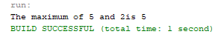

ACTIVITY 2:
  - This activity illustrate concept of void method. Following is a program that defines a method named printGrade and invokes it to print the grade for a given score.

CODE:
package lab;
public class LAB {

public static void main(String[] args) {
System.out.print("The grade is ");
printGrade(78.5);
System.out.print("The grade is ");
printGrade(59.5);
}
public static void printGrade(double score){
if(score >= 90.0){
System.out.println('A');

}
else if(score >= 80.0){
System.out.println('B');
}
else if (score >= 70.0){
System.out.println('C');
}
else if (score >= 60.0){
System.out.println('D');
}
else{
System.out.println('F');
}

}

}
OUTPUT:
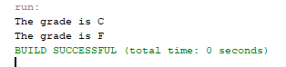

Activity 3:
  - This activity demonstrates the effect of passing by value. Following program creates a method for swapping two variables. The swap method is invoked by passing two arguments.

CODE:

package javaapplication2;

public class JavaApplication2 {

public static void main(String[] args) {
int num1 = 1;
int num2 = 2;
System.out.println("Before invoking the swap method, num1 is " +num1 + " and num2 is " + num2);
// Invoke the swap method to attempt to swap two variables
swap(num1, num2);
System.out.println("After invoking the swap method, num1 is" + num1 + " and num2 is " + num2);
}
/** Swap two variables */
public static void swap(int n1, int n2) {
System.out.println("\tInside the swap method");
System.out.println("\t\tBefore swapping, n1 is " + n1 + " and n2 is " + n2);
// Swap n1 with n2

int temp = n1;
n1 = n2;
n2 = temp;
System.out.println("\t\tAfter swapping, n1 is " + n1+ " and n2 is " + n2);

}
}

OUTPUT:
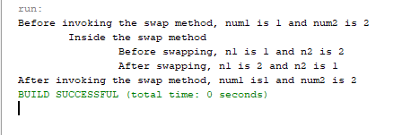

Activity 4:
  - This activity demonstrate the concept of method overloading. In the following program three methods are created. The first finds the maximum integer, the second finds the maximum double,

CODE:

package javaapplication2;

public class JavaApplication2 {

public static void main(String[] args) {
System.out.println("The maximum of 3 and 4 is " + max(3, 4));
// Invoke the max method with the double parameters
System.out.println("The maximum of 3.0 and 5.4 is "+
max(3.0,5.4));
// Invoke the max method with three double parameters
System.out.println("The maximum of 3.0, 5.4, and 10.14 is "
+ max(3.0, 5.4, 10.14));
}

public static int max(int num1, int num2){
if (num1 > num2)
return num1;
else
return num2;
}
/** Find the max of two double values */
public static double max(double num1, double num2){
if (num1 > num2)
return num1;

else
return num2;
}
/** Return the max of three double values */
public static double max(double num1, double num2, double num3){
return max(max(num1, num2), num3);

}
}

OUTPUT:
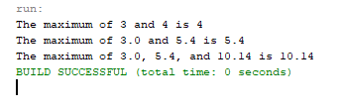

Activity 5:
  - The purpose of this activity is to show the working of recursion. Following is a complete program that prompts the user to enter a nonnegative integer and displays the factorial for number

CODE:
package javaapplication2;
import java.util.Scanner;

public class JavaApplication2 {

public static void main(String[] args) {

Scanner input = new Scanner(System.in);
System.out.print("Enter a nonnegative integer: ");
int n = input.nextInt();
System.out.println("Factorial of " + n + " is " +
factorial(n));
}
public static long factorial(int n) {
if (n == 0) // Base case
return 1;
else
return n * factorial(n - 1); // Recursive call

}
}

OUTPUT:
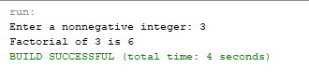

Activity 6:
  - This activity gives a complete program that prompts the user to enter an index and computes the Fibonacci number for that index using the recursion

CODE:

package javaapplication2;
import java.util.Scanner;

public class JavaApplication2 {

public static void main(String[] args) {

Scanner input = new Scanner(System.in);
System.out.print("Enter index for a Fibonacci number: ");
int index = input.nextInt();
// Find and display the Fibonacci number
System.out.println("The Fibonacci number at index " + index
+ " is " + fib(index));
}
/** The method for finding the Fibonacci number */
public static long fib(long index) {
if (index == 0) // Base case
return 0;
else if (index == 1) // Base case
return 1;
else // Reduction and recursive calls
return fib(index - 1) + fib(index - 2);

}
}

OUTPUT:
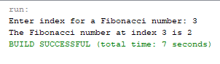
SOLUTION OF LAB TASKS :

Lab Task 1 a)
  - Write a method that computes the sum of the digits in an integer. Use the following method header: public static int sumDigits(long n). For example, sumDigits(234) returns 9 (2 + 3 + 4).

CODE:
import java.util.Scanner;

public class aima {
public static void main(String[] args) {
long num = 234;
System.out.println("Sum of digits in " + num + " is: " + sumDigits(num));
}

public static int sumDigits(long n) {
if (n == 0) {
return 0; // Base case: if no digits left, return 0
} else {
return (int)(n % 10) + sumDigits(n / 10); // Extract last digit and recurse
}

}
}

OUTOUT:

  - b) Write a method with the following header to display an integer in reverse order: public static void reverse(int number) 77 For example, reverse(3456) displays 6543. Write a test program that prompts the user to enter an integer and displays its reversal.

CODE:
import java.util.Scanner;

public class aima {
public static void main(String[] args) {
Scanner input = new Scanner(System.in);
System.out.print("Enter an integer: ");
int num = input.nextInt();
System.out.print("Reversed number: ");
reverse(num);
input.close();
}

public static void reverse(int number) {
if (number < 10) {
System.out.print(number); // Base case: single digit
} else {
System.out.print(number % 10); // Print last digit
reverse(number / 10); // Recurse with remaining digits
}

}
}

OUTPUT:
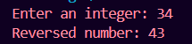

Lab Task 2
  - Write the methods with the following headers // Return the reversal of an integer, i.e., reverse(456) returns 654 public static int reverse(int number) // Return true if number is a palindrome public static boolean isPalindrome(int number) Use the reverse method to implement isPalindrome. A number is a palindrome if its reversal is the same as itself. Write a test program that prompts the user to enter an integer and reports whether the integer is a palindrome.

CODE
import java.util.Scanner;

public class aima {
public static void main(String[] args) {
Scanner input = new Scanner(System.in);
System.out.print("Enter an integer: ");
int num = input.nextInt();

if (isPalindrome(num)) {
System.out.println(num + " is a palindrome.");
} else {
System.out.println(num + " is not a palindrome.");
}

input.close();
}

// Returns the reversal of an integer, e.g., reverse(456) returns 654
public static int reverse(int number) {
int reversed = 0;
while (number != 0) {
reversed = reversed * 10 + number % 10; // Append last digit of 'number' to 'reversed'
number /= 10; // Remove the last digit from 'number'
}
return reversed;
}

// Returns true if the number is a palindrome (uses the reverse method)
public static boolean isPalindrome(int number) {
return number == reverse(number); // Check if original number == reversed number

}
}

OUTPUT:
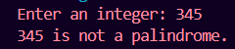
Lab Task 3
  - Write a method with the following header to display three numbers in increasing order: public static void displaySortedNumbers(double num1, double num2, double num3) Write a test program that prompts the user to enter three numbers and invokes the method to display them in increasing order.

CODE:
import java.util.Scanner;

public class aima {
public static void main(String[] args) {
Scanner input = new Scanner(System.in);

System.out.print("Enter the first number: ");
double num1 = input.nextDouble();

System.out.print("Enter the second number: ");
double num2 = input.nextDouble();

System.out.print("Enter the third number: ");
double num3 = input.nextDouble();

System.out.print("Numbers in increasing order: ");
displaySortedNumbers(num1, num2, num3);

input.close();
}

// Method to display three numbers in increasing order
public static void displaySortedNumbers(double num1, double num2, double num3) {
// Temporary variables for swapping
double temp;

// Compare and swap num1 and num2 if necessary
if (num1 > num2) {
temp = num1;
num1 = num2;
num2 = temp;
}

// Compare and swap num1 and num3 if necessary
if (num1 > num3) {
temp = num1;
num1 = num3;
num3 = temp;
}

// Compare and swap num2 and num3 if necessary
if (num2 > num3) {
temp = num2;
num2 = num3;
num3 = temp;
}

// Print the sorted numbers
System.out.println(num1 + " " + num2 + " " + num3);
}
}

OUTPUT:
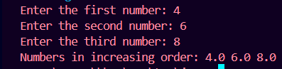
Lab Task 4
  - Write a method that returns the number of days in a year using the following header: public static int numberOfDaysInAYear(int year) Write a test program that displays the number of days in year from 2000 to 2020.

CODE:

public class aima {
public static void main(String[] args) {
System.out.println("Year\tDays");
for (int year = 2000; year <= 2020; year++) {
System.out.println(year + "\t" + numberOfDaysInAYear(year));
}
}

public static int numberOfDaysInAYear(int year) {
if (isLeapYear(year)) {
return 366;
} else {
return 365;
}
}

// Helper method to check leap year
public static boolean isLeapYear(int year) {
return (year % 400 == 0) || (year % 100 != 0 && year % 4 == 0);
}
}

OUTPUT:
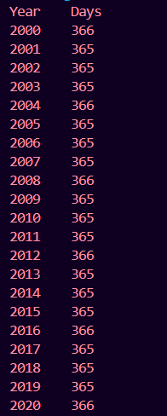
Lab Task 5
  - Write a method that counts the number of letters in a string using the following header: public static int countLetters(String s) Write a test program that prompts the user to enter a string and displays the number of letters in the string.

CODE:
import java.util.Scanner;

public class aima {
public static void main(String[] args) {
Scanner input = new Scanner(System.in);
System.out.print("Enter a string: ");
String s = input.nextLine();
System.out.println("Number of letters: " + countLetters(s));
input.close();
}

public static int countLetters(String s) {
int count = 0;
for (int i = 0; i < s.length(); i++) {
if (Character.isLetter(s.charAt(i))) {
count++;
}
}
return count;
}
}

OUTPUT:
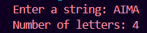
Lab Task 6
  - Write a function capitalize(lower_case_word) that takes the lower case word and returns the word with the first letter capitalized. Eg., System.out.println(capitalize(“word”)) should print the word Word.Then, given a line of lowercase ASCII words (text separated by a single space), print it with the first letter of each word capitalized using the your own function capitalize().

CODE:
public class aima {
public static void main(String[] args) {
Scanner input = new Scanner(System.in);
System.out.print("Enter a line of lowercase words: ");
String line = input.nextLine();
System.out.println(capitalizeLine(line));
input.close();
}

// Capitalize the first letter of a single word
public static String capitalize(String lower_case_word) {
if (lower_case_word == null || lower_case_word.isEmpty()) {
return lower_case_word;
}
return lower_case_word.substring(0, 1).toUpperCase()
+ lower_case_word.substring(1);
}

// Capitalize each word in a line
public static String capitalizeLine(String line) {
String[] words = line.split(" ");
StringBuilder result = new StringBuilder();
for (String word : words) {
result.append(capitalize(word)).append(" ");
}
return result.toString().trim();
}
}

OUTPUT:
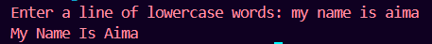
Lab task 7
Write a method that displays an n-by-n matrix using the following header: public static void printMatrix(int n) Each element is 0 or 1, which is generated randomly. Write a test program that prompts the user to enter n and displays an n-by-n matrix.

CODE:
import java.util.Random;
import java.util.Scanner;

public class aima {
public static void main(String[] args) {
Scanner input = new Scanner(System.in);
System.out.print("Enter n: ");
int n = input.nextInt();
printMatrix(n);
input.close();
}

public static void printMatrix(int n) {
Random rand = new Random();
for (int i = 0; i < n; i++) {
for (int j = 0; j < n; j++) {
System.out.print(rand.nextInt(2)); // Random 0 or 1
}
System.out.println(); // New line after each row
}
}
}

OUTPUT:
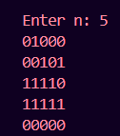
Lab Task 8
  - Write a Java method to count all vowels in a string.

CODE:
public class aima {
public static void main(String[] args) {
String input = "AIMA";
System.out.println("Vowel count: " + countVowels(input)); // Output: 3
}

public static int countVowels(String s) {
int count = 0;
String vowels = "aeiouAEIOU";

for (int i = 0; i < s.length(); i++) {
char c = s.charAt(i);
if (vowels.indexOf(c) != -1) { // Check if the character is a vowel
count++;
}
}
return count;
}
}

OUTPUT:
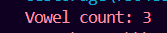
Lab Task 9
  - Given a positive real number a and a non-negative integer n. Calculate an without using loops, ** operator or the built in function math.pow(). Instead, use recursion and the relation an=a⋅an-1. Print the result. Form the method power (a, n).

CODE:
public class aima {
public static void main(String[] args) {
double a = 2.5; // Example base
int n = 3; // Example exponent
System.out.println(power(a, n)); // Output: 15.625
}

public static double power(double a, int n) {
// Base case: a^0 = 1 for any a ≠ 0
if (n == 0) {
return 1;
}
// Recursive case: a^n = a * a^(n-1)
else {
return a * power(a, n - 1);
}
}
}

OUTPUT:

Lab task 10:
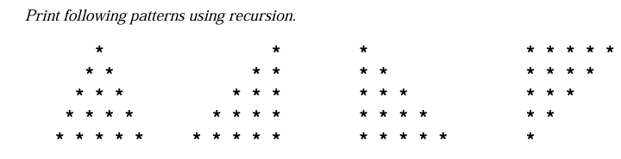

CODE:
public class RecursivePatterns {

// ---------------- PATTERN 1 ----------------
public static void pattern1(int row, int totalRows) {
if (row > totalRows) return;
printSpaces(totalRows - row);
printStars(row);
System.out.println();
pattern1(row + 1, totalRows);
}

// ---------------- PATTERN 2 ----------------
public static void pattern2(int row, int totalRows) {
if (row > totalRows) return;
printSpaces(row - 1);
printStars(totalRows - row + 1);
System.out.println();
pattern2(row + 1, totalRows);
}

// ---------------- PATTERN 3 ----------------
// Pattern 3 is identical to Pattern 1 (same as left-aligned pyramid)
public static void pattern3(int row, int totalRows) {
if (row > totalRows) return;
printSpaces(totalRows - row);
printStars(row);
System.out.println();
pattern3(row + 1, totalRows);
}

// ---------------- PATTERN 4 ----------------
public static void pattern4(int row) {
if (row == 0) return;
printStars(row);
System.out.println();
pattern4(row - 1);
}

// Helper method to print spaces
public static void printSpaces(int count) {
if (count == 0) return;
System.out.print(" ");
printSpaces(count - 1);
}

// Helper method to print stars
public static void printStars(int count) {
if (count == 0) return;
System.out.print("* ");
printStars(count - 1);
}

// ---------------- MAIN ----------------
public static void main(String[] args) {
int totalRows = 5;

System.out.println("Pattern 1:");
pattern1(1, totalRows);
System.out.println();

System.out.println("Pattern 2:");
pattern2(1, totalRows);
System.out.println();

System.out.println("Pattern 3:");
pattern3(1, totalRows);
System.out.println();

System.out.println("Pattern 4:");
pattern4(totalRows);
}
}

OUTPUT:
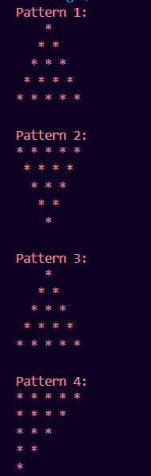

PART A:
  - Given a sequence of integers. Print the sequence in reverse order using recursion.

CODE:
public class ReverseSequence {

public static void printReverse(String input) {
if (input.isEmpty()) {
return;
}
printReverse(input.substring(1));
System.out.print(input.charAt(0));
}

public static void main(String[] args) {
String input = "1234567";
System.out.print("Reversed Output: ");
printReverse(input);
}
}

OUTPUT:

PART B:
  - Given an integer number. Convert it into its equivalent Binary number using recursion.

CODE:
public class DecimalToBinary {

public static void convertToBinary(int num) {
if (num == 0) {
return;
}
convertToBinary(num / 2);
System.out.print(num % 2);
}

public static void main(String[] args) {
int number = 13; // You can change the number here
System.out.print("Binary Output: ");
if (number == 0) {
System.out.print("0");
} else {
convertToBinary(number);
}
}
}

OUTPUT:

PART C:
  - Implement Binary Search algorithm using the recursion.[To perform this task students must have taken the Arrays Lab]

CODE:
public class RecursiveBinarySearch {

public static int binarySearch(int[] arr, int left, int right, int key) {
if (left > right) {
return -1; // Not found
}

int mid = left + (right - left) / 2;

if (arr[mid] == key) {
return mid;
} else if (arr[mid] > key) {
return binarySearch(arr, left, mid - 1, key);
} else {
return binarySearch(arr, mid + 1, right, key);
}
}

public static void main(String[] args) {
int[] arr = {1, 3, 5, 7, 9, 11}; // Sorted array
int key = 7;

int result = binarySearch(arr, 0, arr.length - 1, key);
if (result != -1) {
System.out.println("Element found at index: " + result);
} else {
System.out.println("Element not found.");
}
}
}

OUTPUT:
